Project Design Phase-II
Data Flow Diagram & User Stories

Date | 2-01-2026
Team ID
Project Name | TheBookStop – Online Bookstore Platform
Maximum Marks | 4 Marks

Data Flow Diagram (DFD)
A Data Flow Diagram (DFD) illustrates how data moves within TheBookStop platform. It explains how users (customers, sellers, and admins) interact with the system, how information flows between modules, and where data is stored.
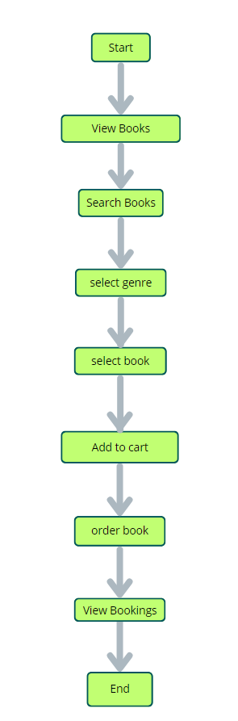
Key Components:
- Users: Browse books, manage carts, place orders, and write reviews
- Sellers: Add, update, and manage books
- Admin: Manages users, sellers, books, and platform activities
- System Database: Stores user data, books, orders, reviews, and transactions
Data Flow Description:
- Users send requests such as login, browsing books, adding items to cart, and placing orders.
- The system processes requests and interacts with the database.
- Sellers upload book details which are stored and displayed to users.
- Admin monitors platform activities and manages users and content.
- The system returns confirmations, order details, and updates to users.
This structured data flow ensures smooth communication between all components and supports scalability and security.

User Stories
User Story Table – TheBookStop
User Type | Functional Requirement (Epic) | User Story / Task | Acceptance Criteria | Priority | Release
User | Book Browsing | As a user, I can browse books by category or search by name. | Books are displayed correctly with filters applied. | High | Sprint-1
User | Cart Management | As a user, I can add books to my cart and view them anytime. | Cart updates correctly and retains items. | High | Sprint-1
User | Order Placement | As a user, I can place an order after checkout. | Order is saved and visible in order history. | High | Sprint-1
Seller | Book Management | As a seller, I can add, update, or delete books. | Book changes reflect immediately. | High | Sprint-1
Seller | Inventory Tracking | As a seller, I can track listed books and stock. | Inventory updates correctly. | Medium | Sprint-2
User | Review System | As a user, I can leave reviews after purchasing books. | Reviews appear on book detail pages. | Medium | Sprint-2
Admin | User Management | As an admin, I can manage users and sellers. | Actions are logged and reflected instantly. | High | Sprint-1
Admin | Order Monitoring | As an admin, I can view all orders placed. | Order data is accurate and accessible. | Medium | Sprint-2

Final Outcome
The Data Flow Diagram and User Stories help visualize system interactions and define clear functional requirements for TheBookStop. This ensures better collaboration, smoother development, and effective feature implementation aligned with user expectations.

